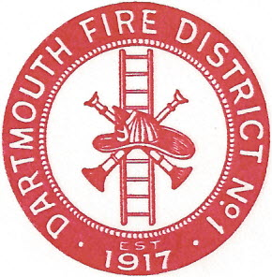
Dartmouth Fire District No.1
10 Bridge Street • Dartmouth, MA 02748
Telephone (508) 996-1596 • Fax (508) 984-4521

Agenda for July 10, 2019 @ 6:00 PM

- Vendor Warrant
- Payroll Warrant
- Equipment maintenance
- Building maintenance
- Website-Civicplus replacing Virtual TownHall
- Meeting Minutes to approve; June 26, 2019, April 10, 2019
- Adjourn,

